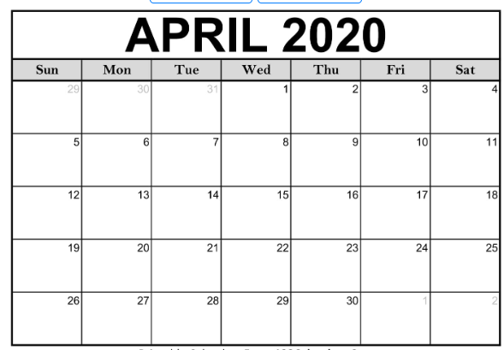

April 3: Parking benefit $46.25

April 10: Parking benefit $46.25

April 17: Parking benefit $46.25

April 24: Parking benefit $46.25

April total: $185